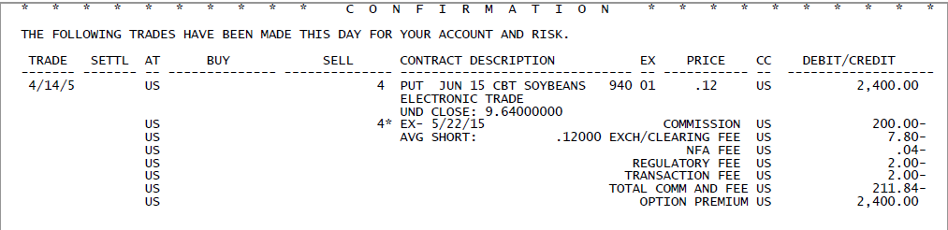
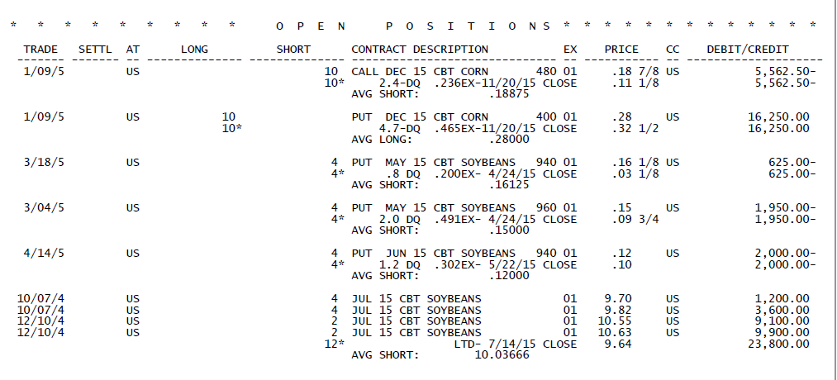
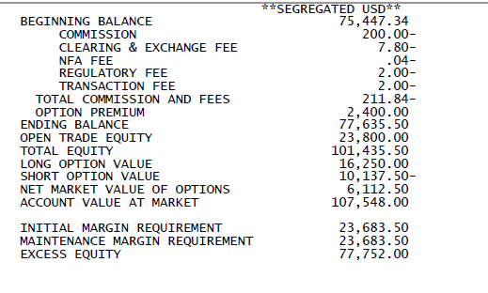

Normally, the most important line item in an account holders statement is the line called “Account Value at Market”, often referred to as “Net Liquidating Value”, or, just “Liquidating Value”. That is what the account is worth at the end of that day, based on settlement prices for that day (not counting what the liquidating commissions would be if the account holder were to actually liquidate the account’s positions). In essence then, this amount represents a snapshot of the account’s value as of the close of business on that day. For the remainder of this explanation, we will simply call that line “Account Value”.
That is not necessarily the amount of money that could be withdrawn from the account at that time, due to margin requirements for any positions currently open (more on this below).
The money in an account is called “equity”. At the beginning of the day, the amount of money, or, equity, in the account is called the “Beginning Balance”, and at the end of each day that figure is called the “Ending Balance”. These balances consist of the following:
- The original amount of money that the account was funded with, plus or minus any additional funds added or withdrawn
- The net amount of total gains and losses of any and all previously closed futures trades.
- Plus the amount of the option premium received from the sale of options
- Minus the amount of option premium paid for the purchase of options
- Less any commissions and/or fees paid for all previous transactions
- The “open trade equity” of any open future positions does not affect the Beginning Balance or Ending Balance.
Importantly, account holders should be aware that the commodities industry accounts for futures positions very different from how it accounts for options positions.
- When a futures trade is entered into, either long or short, as long as that position is open, it is “marked to the market” as of each close. The amount by which it is a profit or a loss is called that trade’s “Open Trade Equity”. This amount refers to the open equity in futures trades only—and does not consider any options positions or values.
- On the other hand, if an option has been purchased, resulting in a new open long options position, the amount paid for that option is deducted from the Beginning Balance and results in a lower Ending Balance at the end of that day.
- Conversely, if an option has been sold, resulting in an open short options position, the revenue received from the sale of that option is added to the Beginning Balance and results in a higher Ending Balance at the end of that day.
- Each day, the amount of whatever the value is of any open options position is listed in the statement. Long options show this figure as a “plus”, and is added to the “Account Balance” for purposes of determining the “Account Value”, whereas short options show this figure as a “minus”, or a subtraction from the “Account Balance” to arrive at the “Account Value”.
- To clarify the last item, consider that the cost of any open long options position has already been deducted from the “Account Balance”. Therefore, it is only fair to have to add back to the value of the account whatever that long option is currently valued at to arrive at an “Account Value” figure. Conversely, the revenue received from the sale of any open short options position has already been added to the “Account Balance”, so whatever that option is currently valued at, which is what it would cost the account holder to buy it back and exit the short position, can be considered a “liability” of the account holder—it is a claim against the value of the account and therefore should be deducted from the “Account Balance” to arrive at a true “Account Value”.

Referring back to the list of line items found on a daily statement, “Total Equity” is arrived at by taking the total of the “Ending Balance” and the “Open Trade Equity” lines, and does not consider the value of any open options positions. The next several lines take that into account.
“Long Option Value” is the current market value of all open long options positions. The “Short Options Value” is the current market value of all open short options positions. The net of these two figures is added or subtracted from “Total Equity” to arrive at the “Account Value at Market”, or, “Liquidating Value”.
The “Initial Margin Requirement” is the total amount of money required by the relevant exchanges for each open position at time of entry of those positions. The “Maintenance Margin Requirement” is the total amount of money required by the relevant exchanges for each open position once the position is established. This might be confusing, but for hedgers these two amounts are usually the same, i.e., “initial margin” and “maintenance margin” are the same amount. (Speculators are generally required to have a higher amount of money posted initially for any new position, and are allowed a bit of leeway, down to the maintenance margin figure, before a margin call results.)
Finally, the “Account Value at Market” less the “Initial Margin Requirement” yields the “Excess Equity”, or the amount of funds that are available for withdrawal by the account holder. Conversely, if the “Account Value at Market” is less than the “Maintenance Margin Requirement” a margin deficiency in that amount exists, which the account holder must meet in due course, or liquidate all or part of the position.
As for daily activity reporting in the statement, on this day, the customer sold 4 June 15 Soybean 940 Puts at a price of 12 cents each. This equates to a flow of funds into the account of $2,400 (5,000 bushels per contract times 12 cents times a quantity of 4). Charges to this inflow of funds include the brokerage commission and four additional small fees levied by the exchange and regulatory organizations. As a general industry practice, the commission is levied on the trade on a “half in/half out” basis for futures trades, whereas options trade commissions are all charged up front, when the trade is entered into, and then there is no commission when the options trade is either offset or the position expires.

